First Seat Test Data:

Movie Selection Test:

Data: Select each movie (Guardians of the Galaxy 3, Five Nights at Freddy's, The Hunger Games).

Explanation: Test if the movie selection process works correctly.

Result: All movies can be selected as expected. And this will open the seat selection screen.

Seat Selection Test:

Data: Select different seats in each row (Row A, B, and C) with varying prices.

Explanation: Check if seat selection displays the correct row and price.

Result: The correct row and price are displayed for each seat. This will then open the confirmation screen.

Purchase Confirmation Test:

Data: Confirm purchase and cancel purchase.

Explanation: Validate the purchase confirmation process.

Result: Confirmation opens a thank-you message, cancel closes the confirmation window.

Exit Test:

Data: Click on the Exit button.

Explanation: Check if the Exit button closes the application.

Result: The application is closed as expected.

Explanation of Results: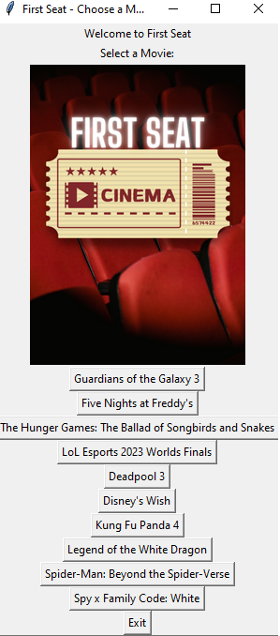

All the test cases passed successfully. The application accurately selects movies, seats, confirms purchases, and exits the program.

Screenshots:

Movie Selection Test:

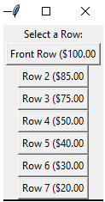

Seat Selection Test:

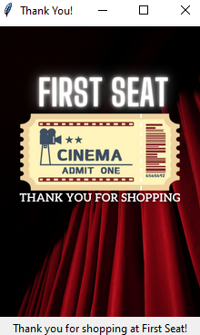

Purchase Confirmation Test:

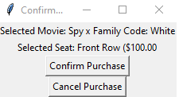

(If purchase is canceled you will be sent back to the movie select screen to rethink your options)

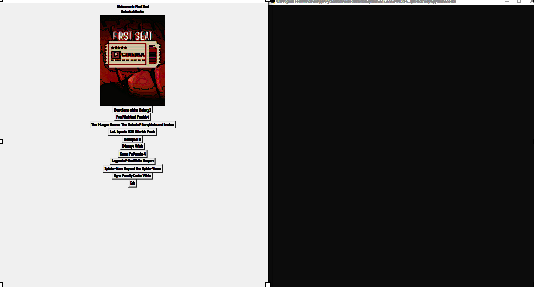

Exit Test:

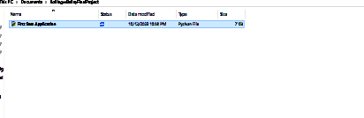

(I show the folder since this indicates clicking exit exits the application same thing would occur with exiting the application after purchases have been made!)

These tests ensure that the program works correctly and provides the intended functionality for movie selection, seat selection, purchase confirmation, and program termination.